Digital to Analog Conversion
In lab 35 you built an external DAC and used it to generate some simple waveforms and in lab 27 you met the PWM system that we use to drive our robot motors.
In this lab you will explore the use of PWM to generate moderate to high accuracy output voltages. These have the advantage of needing minimal external hardware but are limited in the rate at which their values can change. PWM can be a good choice for a slowly varying analog output.
Since PWM is only practical for low frequency outputs, chip manufacturers are starting to put DAC hardware onto their chips. The SAMD51 chip on our Feather boards has two such DACs so we will take a look at what you can do with them.

A Rather Slow DAC
You have seen that a PWM signal is a true digital signal; it is either 0V or 3.3V. However, as we vary the fraction of time that the signal is HIGH we can vary the average voltage all the way from 0V (0% on) to the full 3.3V (100% on). In order to average the PWM we will run the PWM output through a low-pass filter, as we did back in several early labs.
Chapter 8 explains that there is a trade-off between the speed of the PWM and resolution of the signal. Below 2 kHz we can get full 16-bit resolution from our output (65536 different average voltages). Above that we get more speed but less resolution. We will settle for a compromise PWM frequency of 50 kHz, which should get us about 2500 different output values, that is better than 0.1 % resolution, far better than our 8-bit DAC in the last lab.

Step 1
Write a program to produce a ~50% mark-space ratio PWM output at 50 kHz on some suitable pin of your Feather board. Record the output with your scope and paste the image below.
# Ben Kallus
# Produce a 50kHz square wave with a PWMOut

from board import *
from pulseio import PWMOut

FREQ = 50000
RATIO = 0.5
PIN = D6

def main():
pwm = PWMOut(PIN, duty_cycle=int(65535 * RATIO), frequency=FREQ)
while True:1

main()

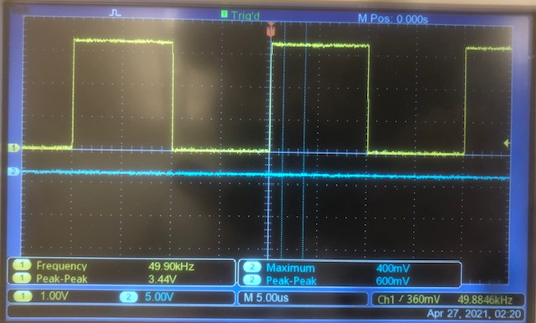

Step 2
We are going to use an improved version of our favorite RC low-pass filter. We have built a filter with a 10k resistor and 0.01µF capacitor. This gives us a filter with a somewhat soft cut-off above 1.59kHz. If we use two sections of filter then we can get a sharper response at the expense of a cut-off at 1 kHz. Here is the circuit that we shall use.
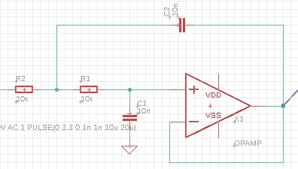
It uses an op-amp (use an LF356) to separate the two sections of the filter (in a very odd way). This allows us to use the same value resistors and capacitors for each section. Build this circuit, drive it with sine waves, and verify that it is a low-pass filter and find the measured cut-off frequency.
This is a low-pass filter. As I increase the frequency of the input wave, the phase shift of the output wave increases and the amplitude of the output wave decreases. When the input wave is 2.06 V P-P, the output wave is 2.06/sqrt(2) = 1.45V P-P at 750MHz. Thus, the measured cut-off frequency is 750MHz.

Step 3
Now disconnect the input from your signal generator and connect it to the PWM output from your Feather. Measure the output voltage and its ripple. Paste an image below and give the average and ripple voltages.
The average output voltage is 1.68 V, and the ripple voltage is 100mV.
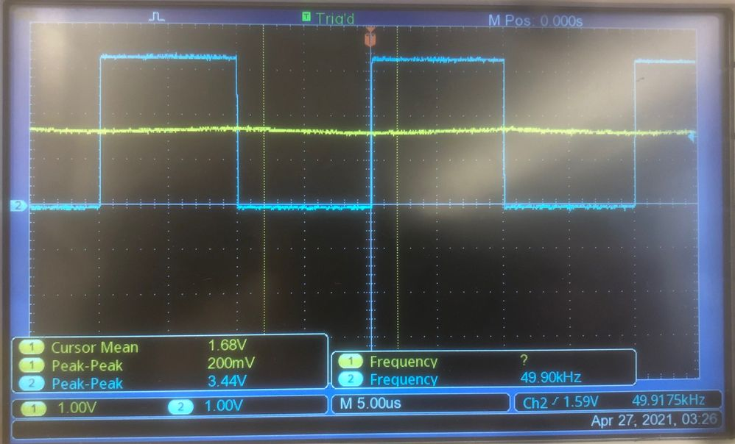

4: PWM Triangle-wave
Modify your program so that it varies the mark-space ratio from 0 to 100% and back again at a steady rate. You need to both increase and decrease at a steady rate without large jumps. For the initial test use 1024 different mark-space ratios (increment = 65536/1024=64) and wait 0.1 ms between steps.
NOTE: Feather will run an interrupt when it feels like it and this will cause a slight irregularity in the slope of your triangle wave. There isn't much we can do about this. It is probably related to garbage collection and clock upkeep, but I haven't tried to dig into the code to find out.
a) Paste an image of the output from your low-pass filter and explain its shape and its frequency.
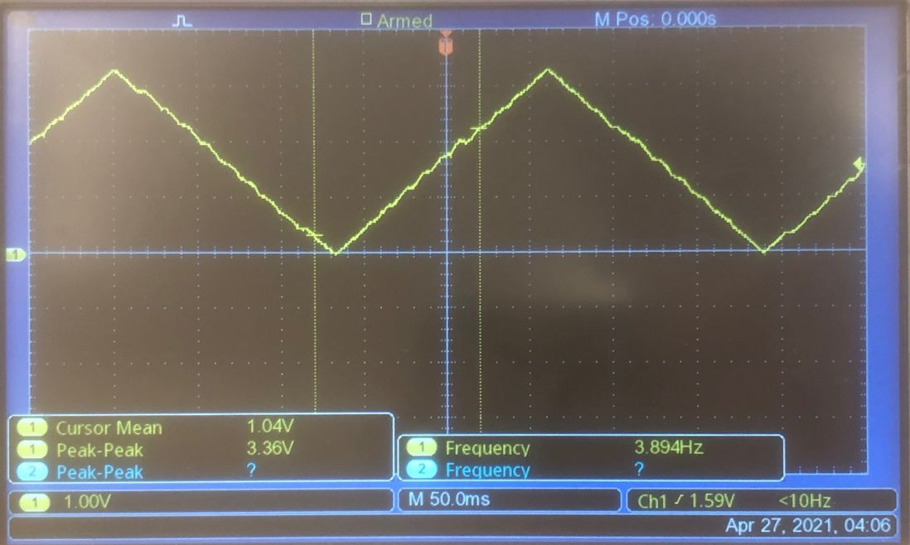
As the mark-space ratio increases, the output voltage from the low-pass filter increases, and when the ratio decreases, the output voltage decreases. This explains why we see two linear slopes that form a triangle wave.

b) Discuss the quality of the output wave.
The wave has small distortions as mentioned above. Aside from these, though, the wave is a very good triangle wave; better than the one we made in lab 35.

c) Experiment with different frequencies for the output wave and find the maximum sensible frequency that you can produce by this method with this filter. Paste an image of your best result below.
The maximum frequency I could get was 3.42Hz. It had a huge ripple.
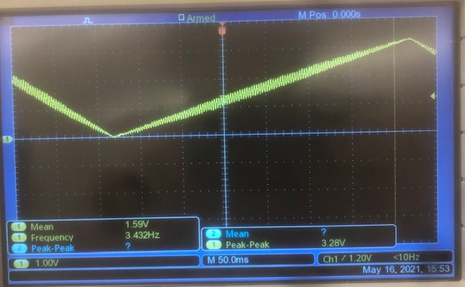

d) Briefly discuss what you have learned about the relationship between the ripple on the output of a PWM DAC and the highest frequency at which it will operate.
The lower the ripple, the lower the frequency. Higher frequency→higher ripple.

Task 3: A Fairly Fast DAC
Use what you learned from section 9.3 in the computer book to generate the same triangle wave (output steps of 64 units) using one of the internal DACs.
a) Paste your new program below.
# Ben Kallus
# Make a triangle wave with a built-in DAC.

from board import *
from pulseio import PWMOut
from audioio import AudioOut, RawSample
import time
import math
from array import array

FREQ = 50000
PIN = D6
DAC_PIN = A0
STEP = 64

def main():
triangle_array = array('H', list(range(0, 65536, STEP)) + list(range(65535, 0, -STEP)))
buff = RawSample(triangle_array, channel_count=2, sample_rate=1000000)
dac = AudioOut(A0, quiescent_value=0)
dac.play(buff, loop=True)
while 1:1

main()

d) Discuss your findings and describe the highest frequency, high quality triangle wave that you have produced.
The highest quality triangle wave I could generate was with a step of 8. Any smaller and the array takes up too much armor.
The highest frequency I could produce was 3.07 kHz. Any more than that, and the wave looks round enough that I wouldn’t call it a triangle wave.

